

CS251: Software Engineering I

2014-2015

Project Title : Social Network

Software Requirements Specifications

**for social network**

TA/ Mohamed Samir (m.samir@fci-cu.edu.eg)

Leader Name: Laila Hussein Zahran (laila.zahran@stud.fci-cu.edu.eg)

Contents

Team 2

Document Purpose and Audience 3

System Models 4

System Decomposition 4

Class diagrams 4

Sequence diagrams 6

Class - Sequence Usage 7

Physical Entity-Relationship Diagram 7

User Interface Design 8

Screen 1 – Sign up and sign in Screen 8

Screen 2 – Home page Screen 8

Ownership Report 9

Policy Regarding Plagiarism: 9

Authors 9

# Team

|  |  |  |  |
| --- | --- | --- | --- |
| **ID** | **Name** | **Email** | **Mobile** |
| 20120281 | Laila Hussein Zahran | Laila.zahran@stud.fci-cu.edu.eg | 01154447815 |
| 20120429 | Nehal Mahmoud Elsawy | Nehalelsawy759@yahoo.com | 01015419166 |
| 20120244 | Aliaa Hassan Amin Habib | Blackrose_10394@hotmail.com | 01065199555 |

# Document Purpose and Audience

* This document is presenting a software requirements specifications, which is a description of a software system to be developed, laying out functional, non-functional requirements, and system models. It is for a back-end API (Application Programming Interface) for a Social Network, which is a dedicated website which enables users to communicate with each other by posting information, comments, messages, images, like Facebook, etc..
* It targets developers (to be able to maintain or develop functions), software engineers and business developers who are trying to develop their professional network or create a new one.
* It targets also the project manager, who is responsible for the whole project.

# System Models

## System Decomposition

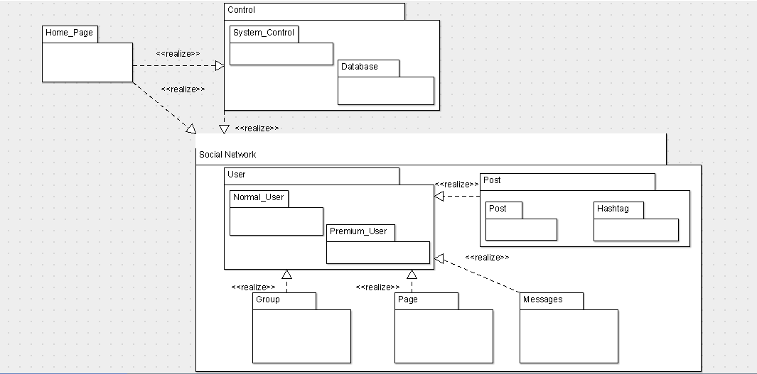

## Class diagrams

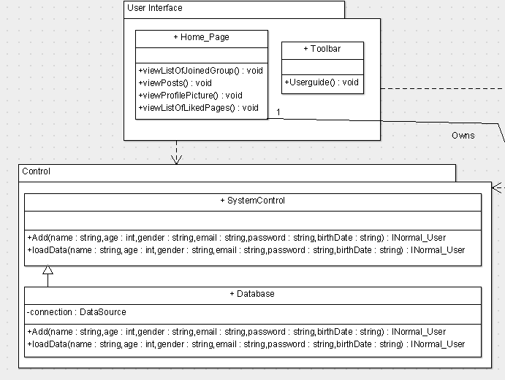 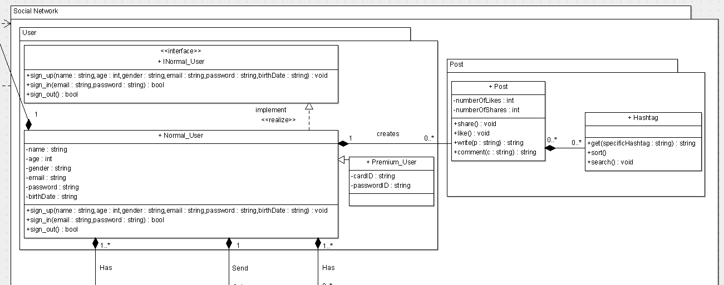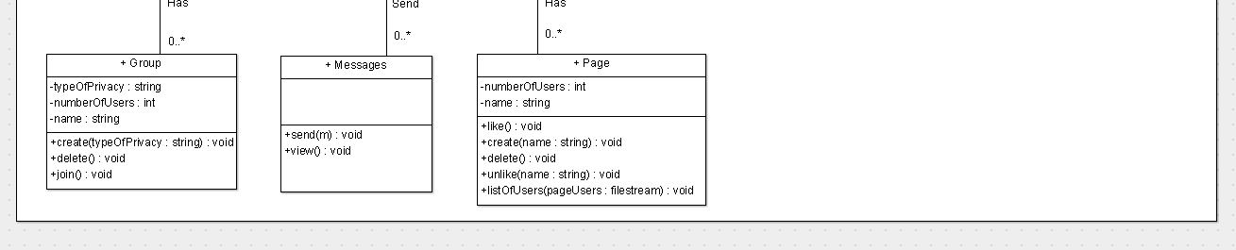

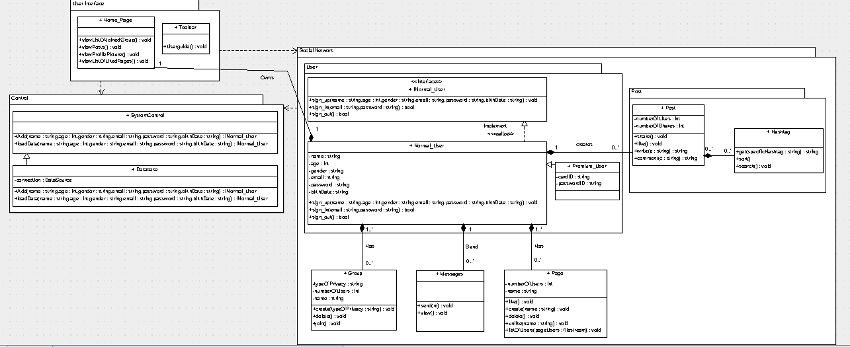

| **Class ID** | **Class Name** | **Subsystem ID** | **Description** |
| --- | --- | --- | --- |
| 1 | SystemControl | 1 | - It is a controller class, relates the actors actions to the entity classes and to the boundary classes.  - It executes the functions (load and add) |
| 2 | Database | 1 | - It's a controller class, relates the actors actions to the entity classes and to the boundary classes.  - It inherits from its parent class (SystemControl). |
| 3 | NormalUser | 2 | - It's an entity class, carries the attributes of the user and the functions he can performs (sign up/ sign in/ sign out) |
| 4 | PremiumUser | 2 | - It's an entity class, carries the attributes of the premium user and the functions he can performs. It inherits from the NormalUser class and adds some extra attributes (cardID/ passwordID) |
| 5 | Post | 3 | - This class is responsible of different types of posts and managing them using some functions (share/ like/ write/ comment). |
| 6 | Hashtag | 3 | - This class is responsible of getting and sorting the hashtags written in posts. |
| 7 | Messages | 4 | This class is responsible of sending or viewing messages. |
| 8 | Pages | 4 | This class is responsible of creating and managing pages by (create / delete) and enables the user to like of unlike the page. |
| 9 | Groups | 4 | This class is responsible of creating managing, and deleting owned groups. It enables the user to join a group. In case of creating the group, it'll enable the owner to choose the type of privacy and its name. |
| 10 | HomePage | 5 | - It's a boundary class. It represents the home page for the user and the list of things that he can view. |
| 11 | Toolbar | 5 | - It's a boundary class. It shows the toolbar to the actor, where he can call the user guide function. |

## Sequence diagrams

**Sequence#1:**

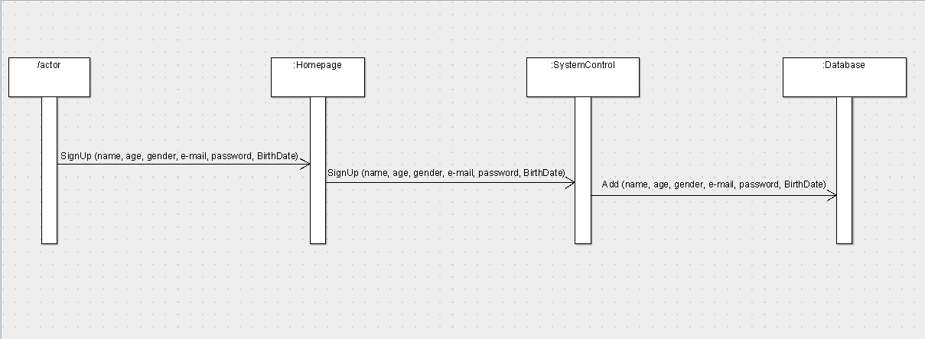**Sequence#2:**

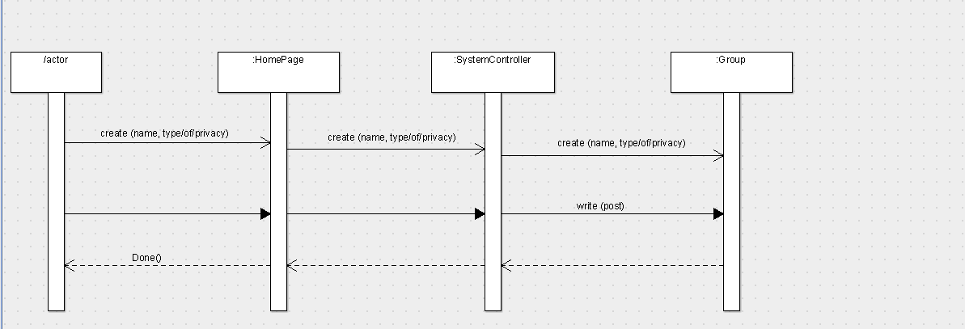

### 

### Class - Sequence Usage

| **Class Name** | **Sequence Diagrams** | **Overall used methods** |
| --- | --- | --- |
| HomePage | 1, 2 | SignUp |
| SystemController | 1,2 | Add |
| Group | 2 | Create, write |
| DataBase | 1 | Add |

## 

## Physical Entity-Relationship Diagram

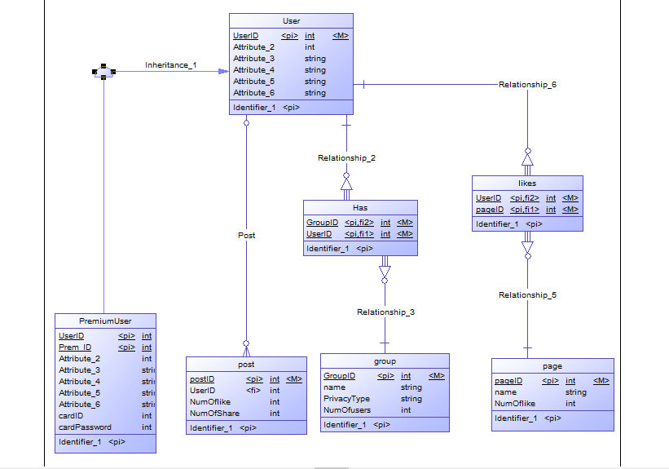

## User Interface Design

### Screen 1 – Sign up and sign in screen

### Screen 2 – Home page screen

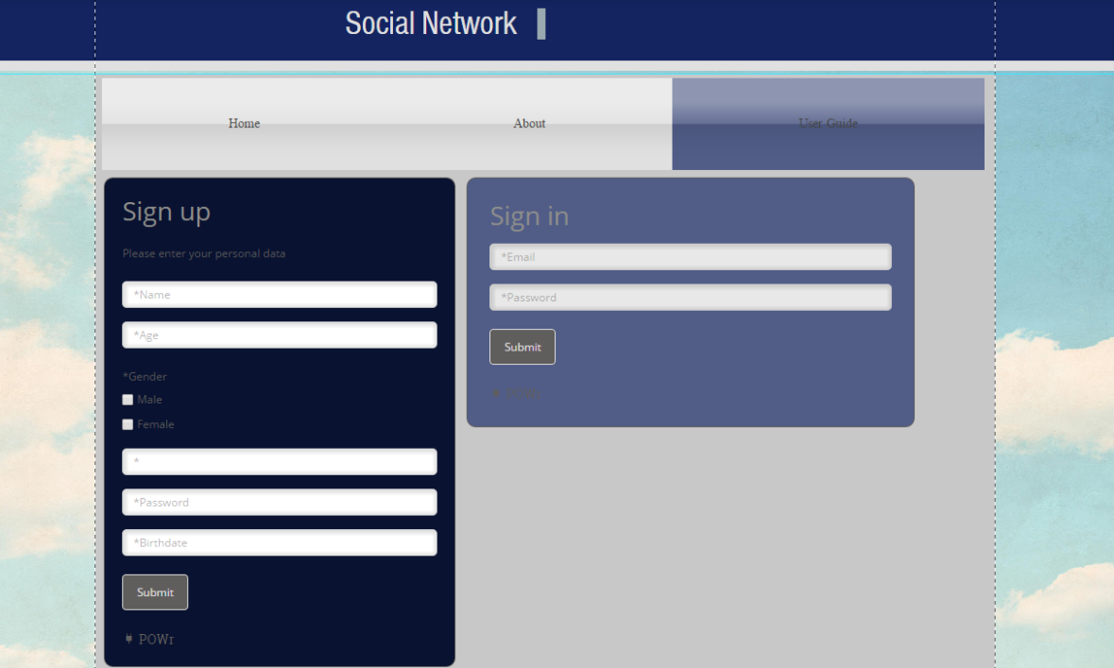

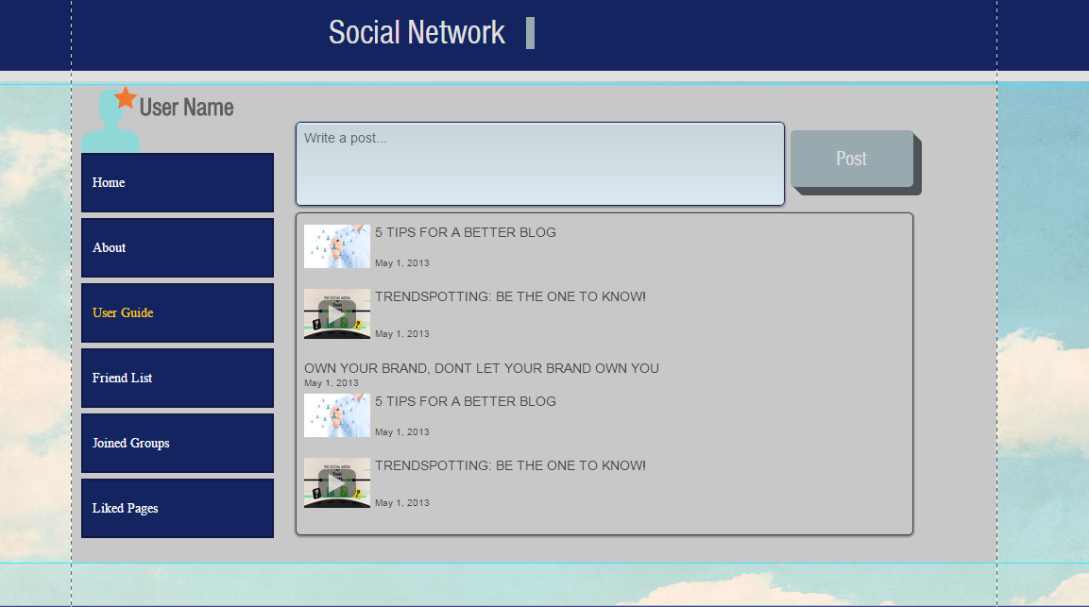

# Ownership Report

|  |  |
| --- | --- |
| **Item** | **Owners** |
| System decomposition | Laila Hussein |
| Class Diagram | Laila Hussein |
| Sequence Diagram | Nehal Mahmoud & Aliaa Hassan |
| Sequence Usage | Nehal Mahmoud & Aliaa Hassan |
| Physical Entity-Relationship Diagram | Nehal Mahmoud & Aliaa Hassan |
| User Interface Design | Laila Hussein |

# Policy Regarding Plagiarism:

# Authors

* Laila Hussein
* Nehal Mahmoud elsawy
* Aliaa hassan